SECTION 1 - Light Emitting Diodes
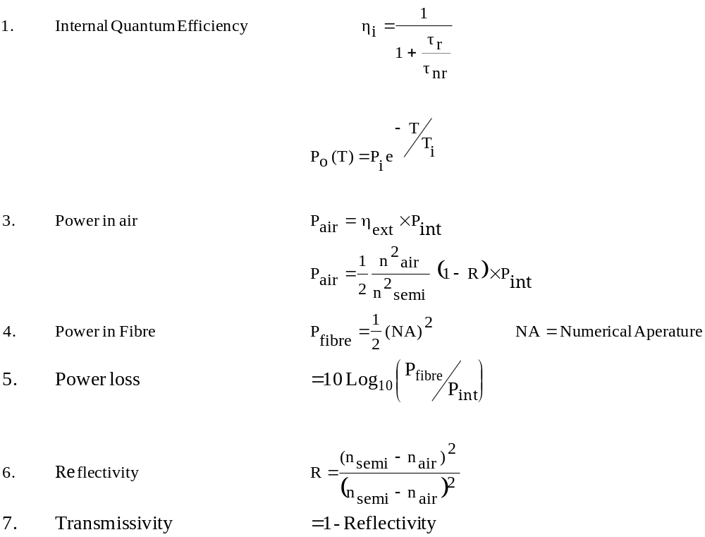

The transmissivity of more than one interface can be found from the product of their transmissivities.
